**Human-Centred Systems Design Group Project**

**Report**

Introduction

As the groups for this project were chosen in pairs, we decided we would work most efficiently by mainly splitting the work between the pairs. Alex and Tom mainly covered the UML and Java implementation of the SQL, while Malvin and Huzaifa did the GUI/ Java Swing.  We communicated using a group chat and we would share our work over github. We would also meet up once a week after the Thursday COM2002 lecture to talk about any issues we were having and keep each other updated on our work.

UML use case diagram

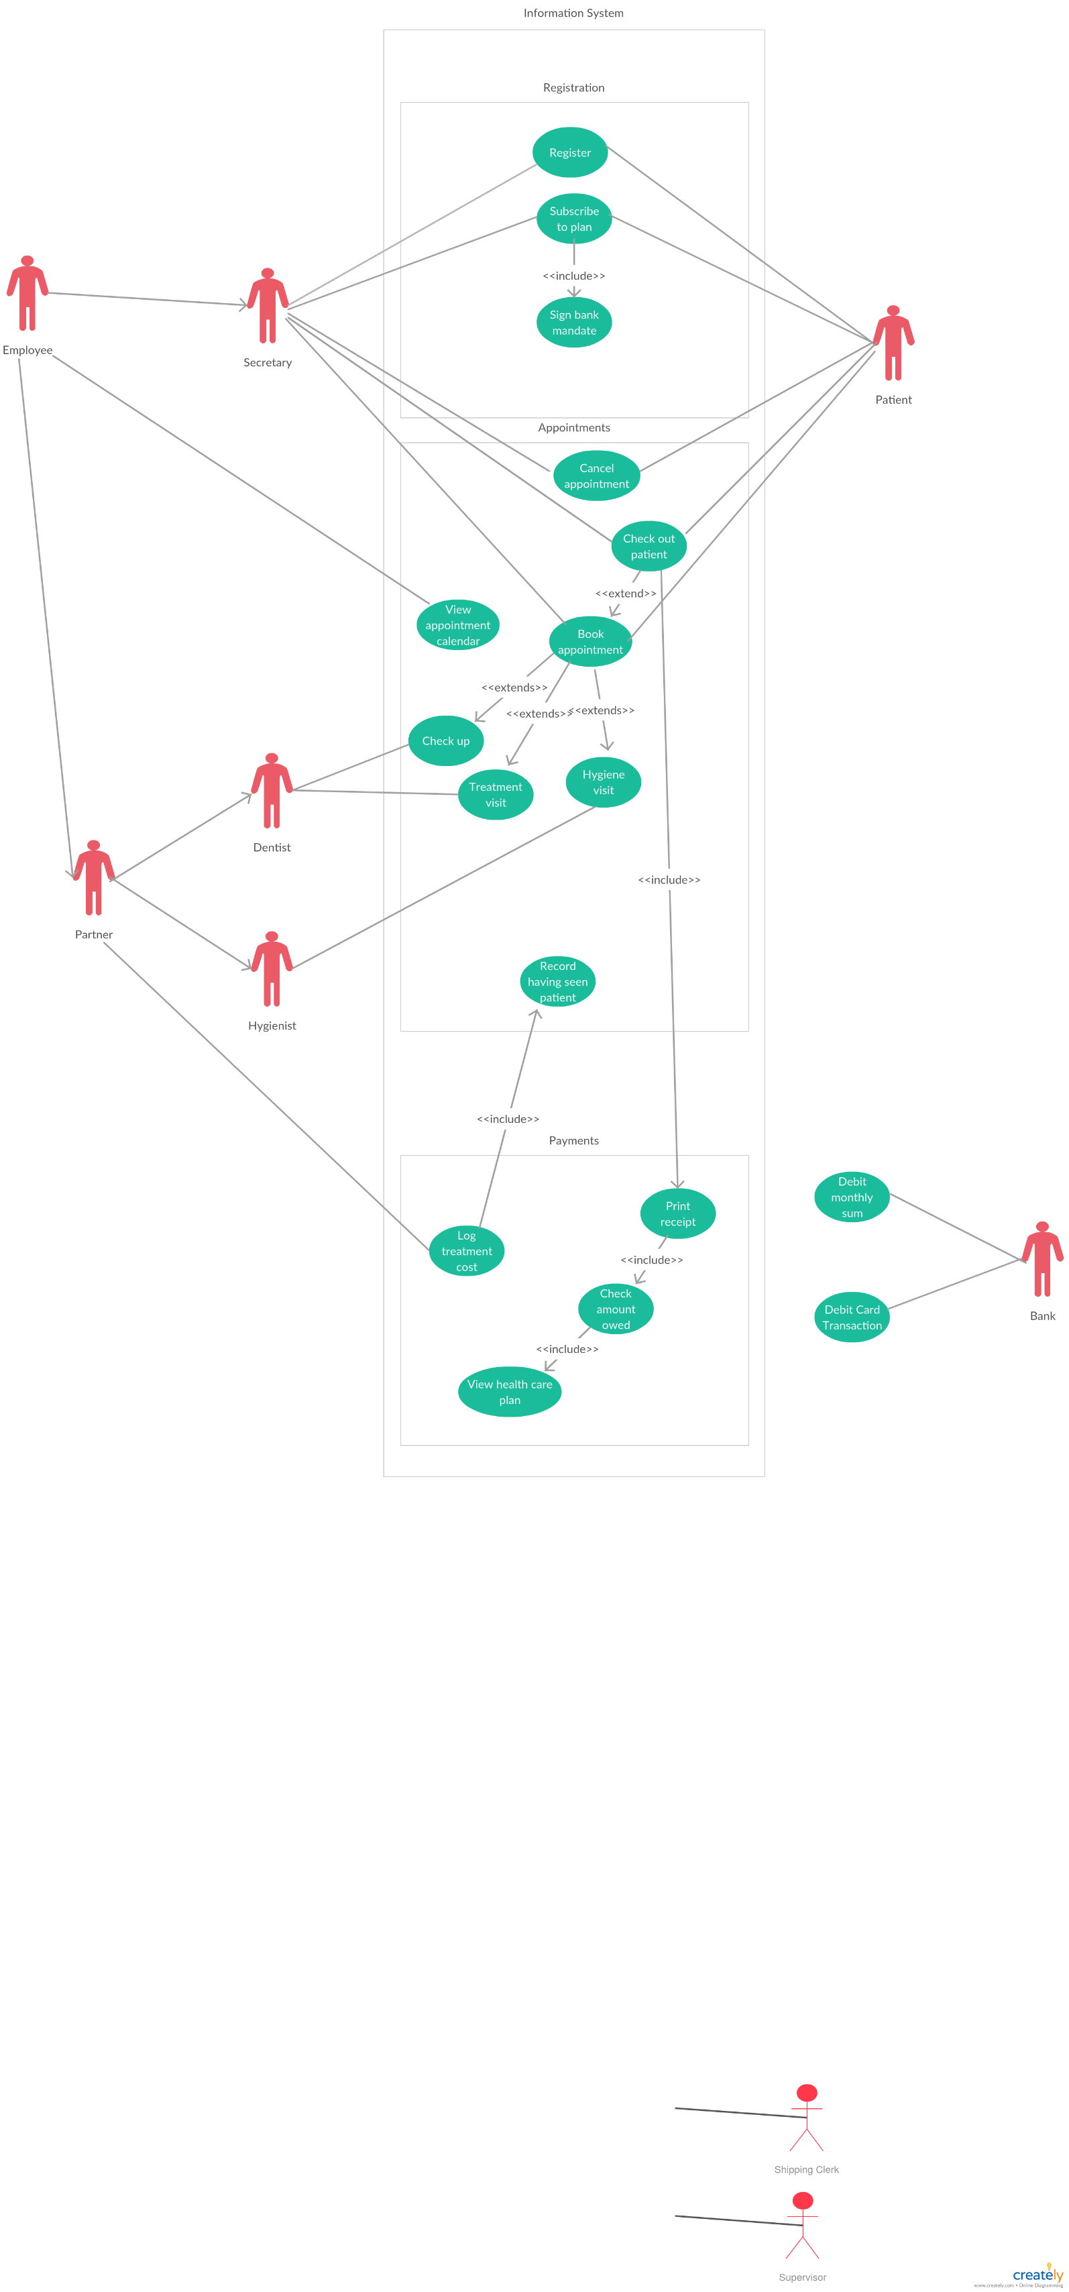

UML information model

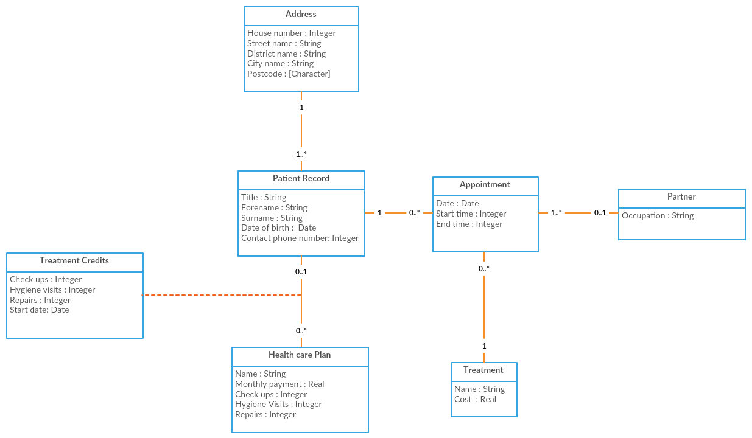

Comments on class diagrams:

* I have indicated the multiplicity from appointment to patient as 1 to mean there is always a patient at each appointment even if said patient has a blank record to indicate a partner holiday
* Treatment credits shows the attributes of the association between a patient and its healthcare plan

UML normalised data model

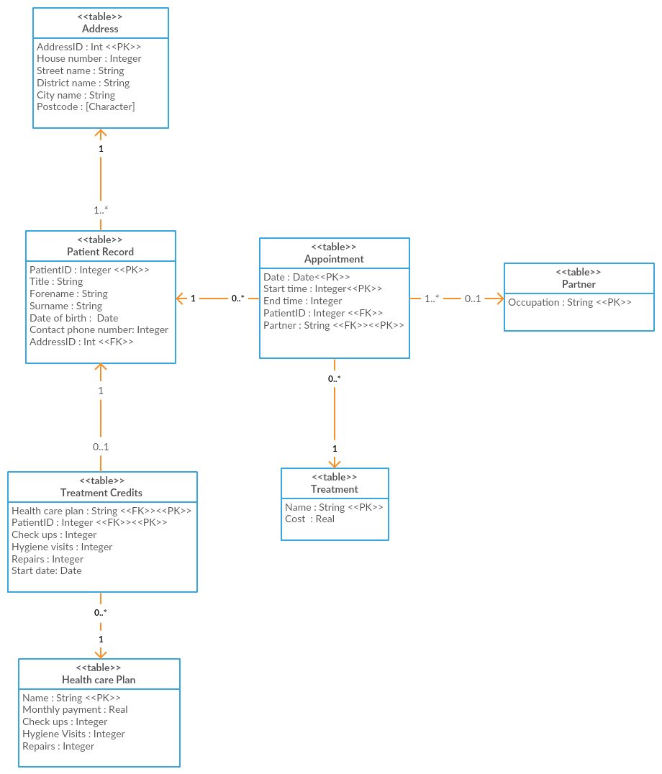

Secretary UI screenshots

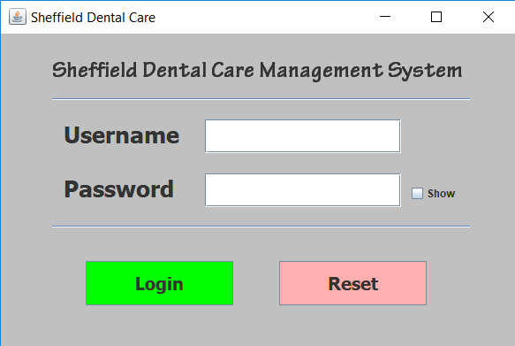

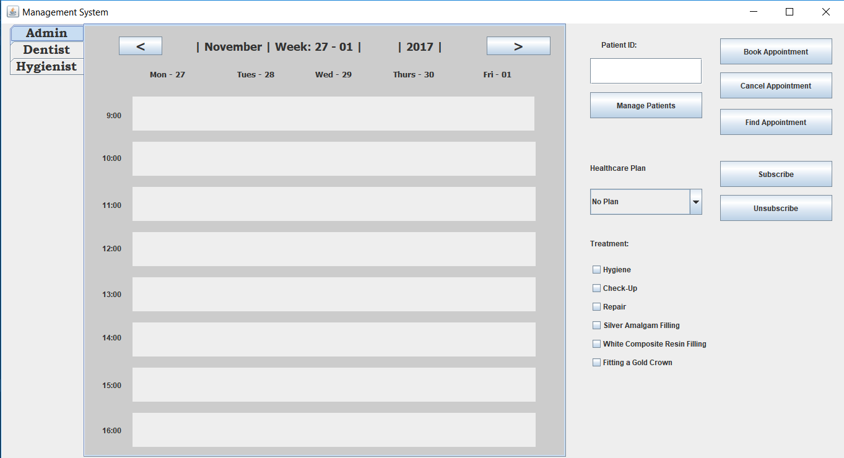

Partner UI screenshots

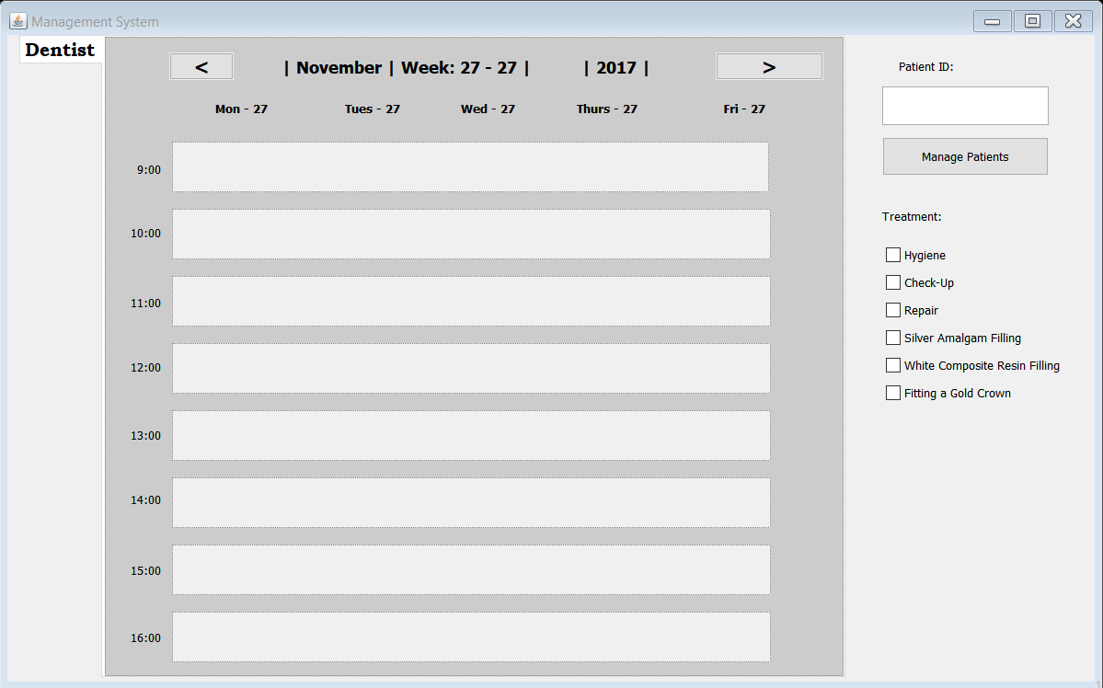

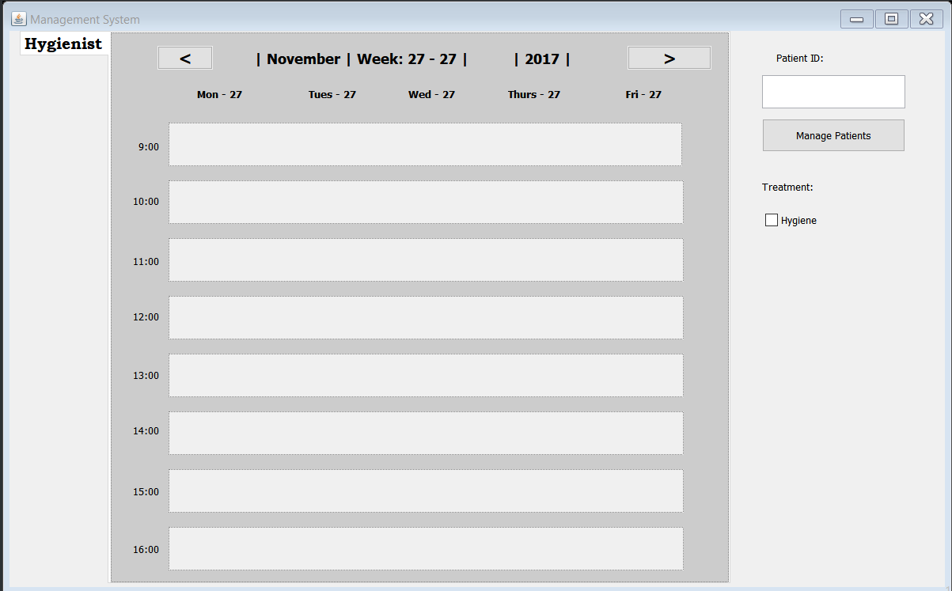

Evidence of query processing

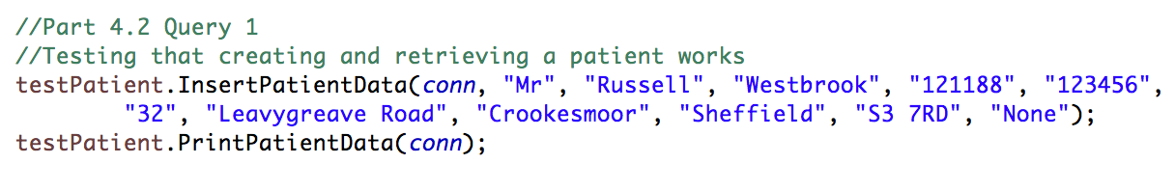

Console Output:

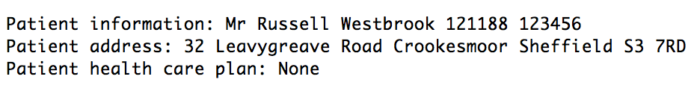

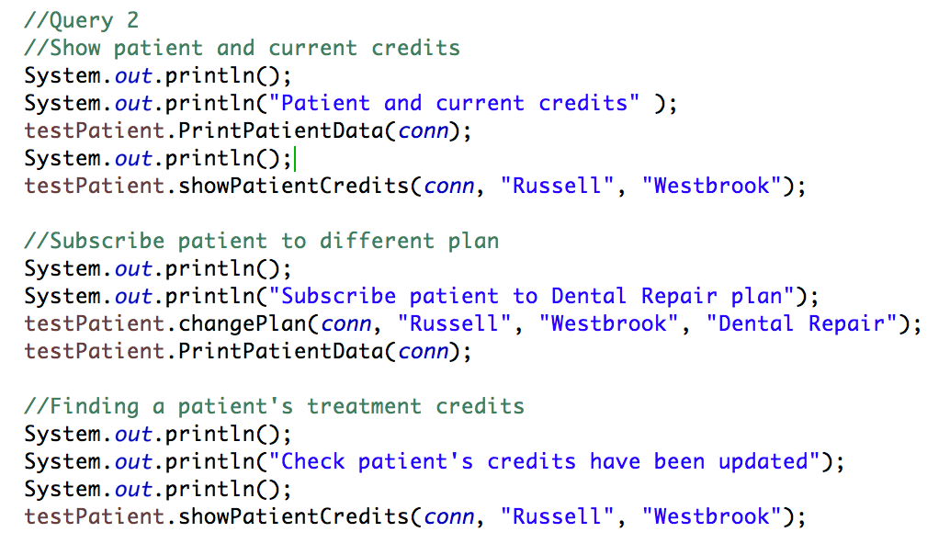

Console Output:

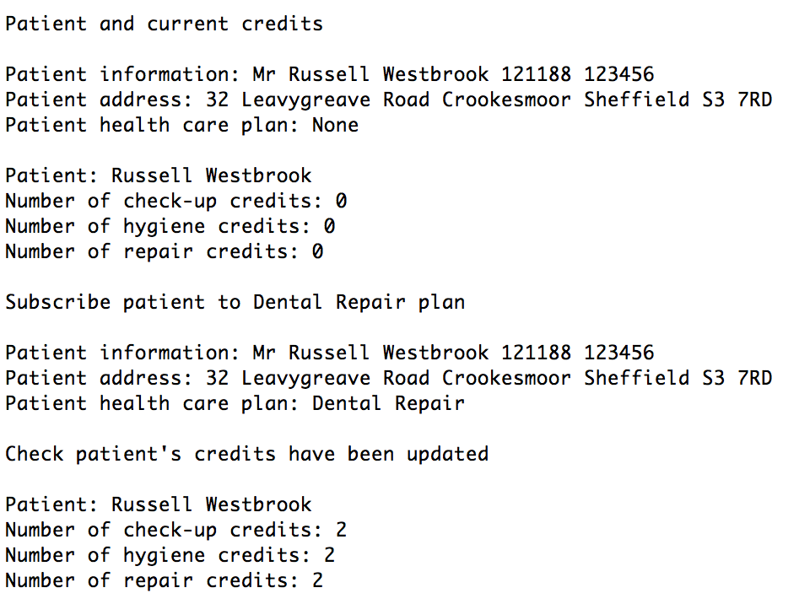

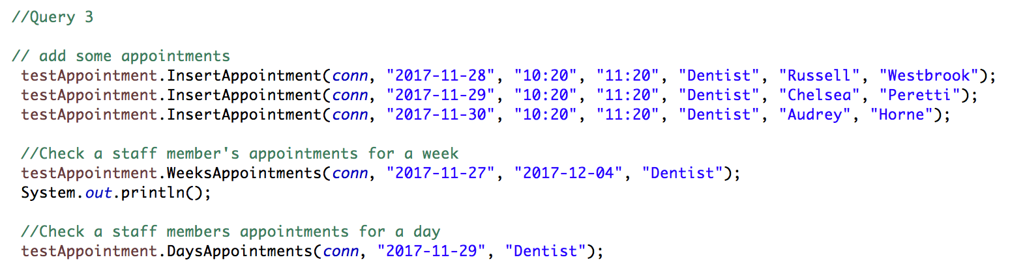

Console Output:

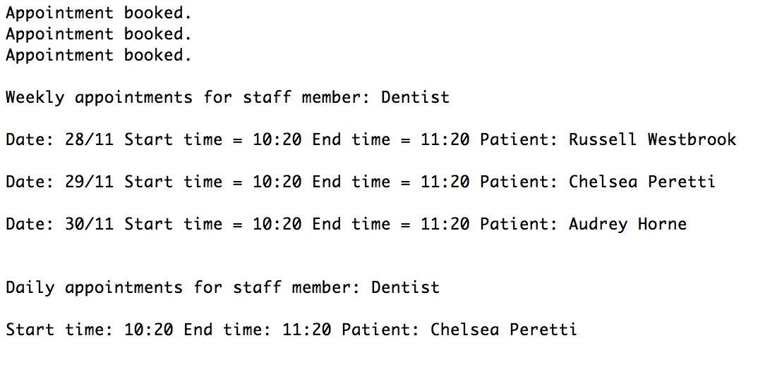

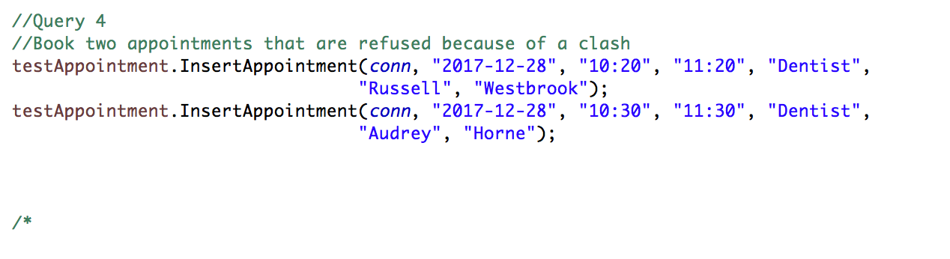

Console Output:

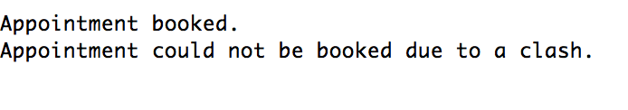

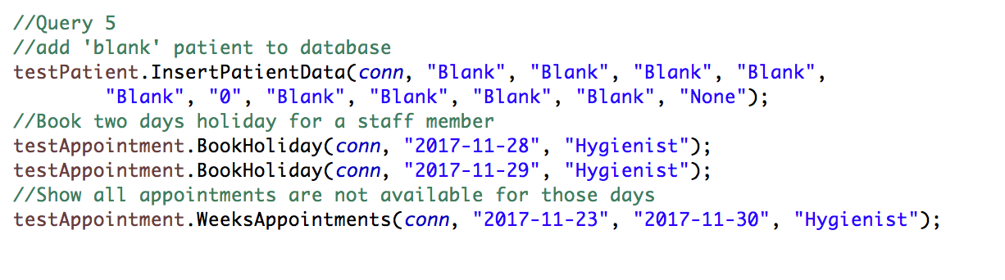

Console Output:

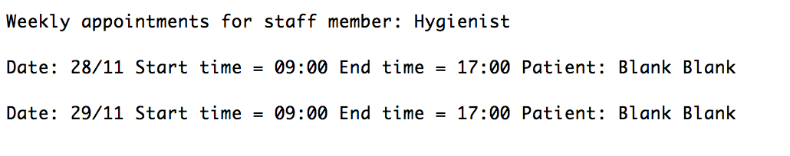

Signed Effort declaration

The team worked effectively with each other from the get go, we helped each other with problems whenever we met up each week and all played an active role throughout. We did however underestimate the size of the task, so our time management could be improved. We ran into a problem trying to get our SQL to work with the university database however at the end.

|  |  |
| --- | --- |
| **Team Member** | **Work done** |
| Huzaifa Ahmed | * Helped Malvin with Java * Did Calendar and Appointment files * Helped Malvin with Debugging * Helped with file management |
| Malvin Todorov | * Helped Huzaifa with Java * Java Login System * Calendar display * Fix bugs |
| Tom Anderson | * SQL database design * Java implementation of SQL * Helped Alex with UML |
| Alex Brown | * Use case diagram * Information model class diagram * Data model class diagram * Helped Tom with SQL |

|  |  |
| --- | --- |
| **Team Member** | **Effort (%)** |
| Huzaifa Ahmed | 100 |
| Malvin Todorov | 100 |
| Tom Anderson | 100 |
| Alex Brown | 100 |

|  |  |
| --- | --- |
| **Team Member** | **Signature** |
| Huzaifa Ahmed |  |
| Malvin Todorov |  |
| Tom Anderson |  |
| Alex Brown |  |